9. Illustrate the concept of inter-process communication using shared memory with a C program

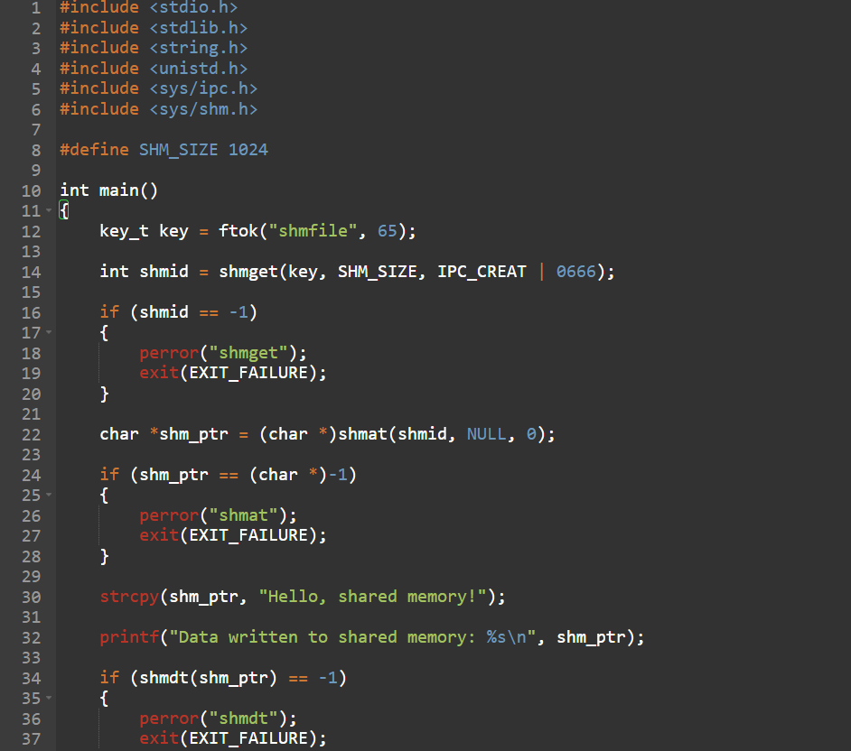

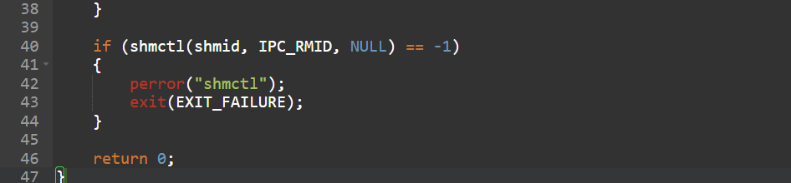

OUTPUT:
